      - SYNOPSYS

Credit This project is about predicting whether a bank customer will leave the bank or stay. The dataset contains information such as age, credit score, balance, salary, and more. The main column we want to predict is “Exited,” which shows if a customer has churned (1) or not (0).

Before training the models, the data is cleaned by filling missing values and scaling the numbers so they are easier for the algorithms to understand. Categorical details like gender and geography are also prepared properly. After cleaning, the data is split into training and testing parts for fair evaluation.

Several machine learning models—like Logistic Regression, KNN, Decision Tree, Random Forest, SVM, and Naive Bayes—are used to see which one predicts churn the best. Their accuracy and reports help compare the results. The goal is to create a model that can help the bank understand which customers are likely to leave so they can take action in time.

2. PREAMBLE
Technological growth has resulted in the rapid increase of online financial transactions. With this growth, fraudulent activities have also expanded. Traditional rule-based systems are no longer sufficient due to complex fraud patterns. Machine learning provides an intelligent and automated way to detect anomalies.
This project uses ML techniques to classify transactions as fraud or genuine.

- General Introduction

This project is about understanding why bank customers leave and how we can predict it using data. The dataset contains information like age, credit score, balance, salary, gender, and geography. The main focus is on the “Exited” column, which shows whether a customer stayed or left the bank. By using machine-learning models, the project aims to find patterns that can help the bank understand customer behavior.

- Statement of Problem

Banks face financial and customer-relationship losses when clients unexpectedly leave the bank.
Major problems:
- Hard to detect customer leaving early.
- Customers leave for many changing reasons.
- Fewer customers leave, many customers stay.
- Bank needs fast and accurate churn prediction.
Problem:
How can machine learning be used to accurately predict customer churn from an imbalanced banking dataset so that the bank can identify at-risk customers in advance?

- Objective and Scope of the Study

Objectives
The primary objectives of the Churn Prediction project are:
- To study customer data and find what causes customers to leave.
- To build machine learning models to predict which customers may leave.
- To check model performance using accuracy and reports.
- To handle the uneven data for better results.
- To create a simple and reliable system to detect customers who may leave.

Scope
This project includes data cleaning, scaling, and training machine-learning models to predict which customers may leave the bank. It focuses on supervised classification using Python libraries and does not cover deployment into real banking systems.
- Covers data cleaning, scaling, model training, and evaluation.
- Focuses on supervised classification to predict customer leaving.
- Uses Python, Pandas, NumPy, Scikit-learn , and Matplotlib.
- Tests models like Logistic Regression, KNN, Decision Tree, Random Forest, SVM, and Naive Bayes.
- Uses methods to manage uneven data between customers who stay and leave

- Module Description with functionality

1. Data Collection Module
- Load the Churn_Modelling.csv file into a DataFrame.
- Check columns and basic structure (features and the target Exited).

2. Data Preprocessing Module
- Fill missing numeric values with the mean and categorical with the most common value.
- Encode categorical fields if needed and drop irrelevant columns

3. Feature Scaling Module
- Apply MinMaxScaler to numeric features so values fall between 0 and 1.

4. Exploratory Data Analysis (EDA)
- Distribution of fraud vs. non-fraud
- Correlation study
- Visualization patterns

5. Model Building Module
- Train classifiers: Logistic Regression, KNN, Decision Tree, Random Forest, SVM (RBF), and Naive Bayes.
- Use consistent training loop to fit each model and get predictions.

6. Model Evaluation Module
- Calculate accuracy, confusion matrix, and full classification reports (precision, recall, F1).
- Compare models to choose the best performer.
7. Prediction Module
- Use the selected model to predict Exited for new customer records.
- Output simple labels (leave/stay) and supporting probabilities if available.

- Methodology

1. Dataset Understanding
Load the credit card fraud dataset and analyze its shape and imbalance.

2. Data Preprocessing
- Normalize “Amount” and “Time”
- Balance dataset using undersampling or SMOTE

3. Feature Selection
Choose relevant PCA features and transaction amount

4. Model Training
Train ML models such as Logistic Regression, Random Forest, and SVM.

5. Evaluation
Use confusion matrix and classification metrics.

6. Result Interpretation
Select the best model based on recall (important for fraud detection).

7. Final Integration
Build prediction function for real-world use.

- Feasibility Study

1. Technical Feasibility
- Uses Python & ML libraries (Scikit-learn, NumPy, Pandas).
- Runs easily on normal computer hardware.
- Technically feasible.

2. Economic Feasibility
- Tools are open-source, so the cost is minimal.
- Dataset is publicly available (free).
- Economically viable.

3. Operational Feasibility
- Easy to use ML workflow.
- Can be implemented by banks or fintech with slight modifications.
- Supports real-time analysis.

4. Schedule Feasibility
- Project can be completed within academic timelines (4–6 weeks).

3. REVIEW OF LITERATURE

Many studies on customer churn show that companies use machine learning to predict which customers may leave. Earlier, simple rule-based systems were used, but they were not good at finding new patterns. Research now recommends models like Logistic Regression, Decision Trees, Random Forest, and SVM because they give better accuracy for churn prediction.

Researchers also say that churn datasets are usually imbalanced, meaning fewer customers leave compared to those who stay. Because of this, methods like SMOTE or class weights are used to improve the prediction of the minority class. Studies also highlight the need for proper data cleaning and handling missing values, encoding categorical columns, and scaling numbers similar to the steps used in your churn modelling code.

Most studies say it is better to try many models and compare their results, just like you used Logistic Regression, KNN, SVM, Naive Bayes, Decision Tree, and Random Forest. They also advise checking more performance measures such as ROC-AUC and F1-score, not only accuracy. Researchers further suggest using feature importance or SHAP to understand which factors, like age, balance, or activity level, make a customer more likely to leave.

Machine learning can predict which customers may leave. Churn data is usually imbalanced, so SMOTE or class weights help. Cleaning and scaling the data improve results. Trying different models helps find the best one. Feature importance shows why customers leave.

4. TECHNICAL DESCRIPTION

- Hardware Requirements

Component | Minimum Requirement | Recommended Requirement
Processor (CPU) | Intel i3 or equivalent | Intel i5/i7 or Ryzen 5
RAM | 4 GB | 8–16 GB (better for ML processing)
Storage | 10 GB free space | 20+ GB free space (for datasets & models)
Graphics | Not required | Optional GPU (only if using deep learning)
System Type | 32/64 bit | 64 bit
Display | Normal display | Full HD

- Software Requirements

Software | Version / Details | Purpose
Operating System | Windows 10 / 11, Linux, macOS | To run code and tools
Python | Python 3.8+ | Main programming language
Jupyter Notebook / Google Colab | Latest | For writing and running ML code
Anaconda (optional) | Latest distribution | For package & environment management
Libraries (Python) | NumPy, Pandas, Scikit-Learn, Matplotlib, Seaborn | For data processing, ML models, visualization
IDE | VS Code / PyCharm / Jupyter Notebook | For coding
Dataset | Credit Card Fraud Dataset (CSV) | Model training and testing

5. SYSTEM DESIGN AND DEVELOPMENT

System Design:

Flowchart / Algorithm with steps:

- Algorithm:
- Step 1: Load dataset
- Step 2: Replace missing values using SimpleImputer
- Step 3: Encode categorical values using LabelEncoder
- Step 4: Scale numerical values using MinMaxScaler
- Step 5: Split data into training and test sets
- Step 6: Train models using different algorithms
- Step 7: Evaluate model performance using metrics
- Step 8: Visualize data using heatmap, scatter, boxplot, and histogram

Flowchart:

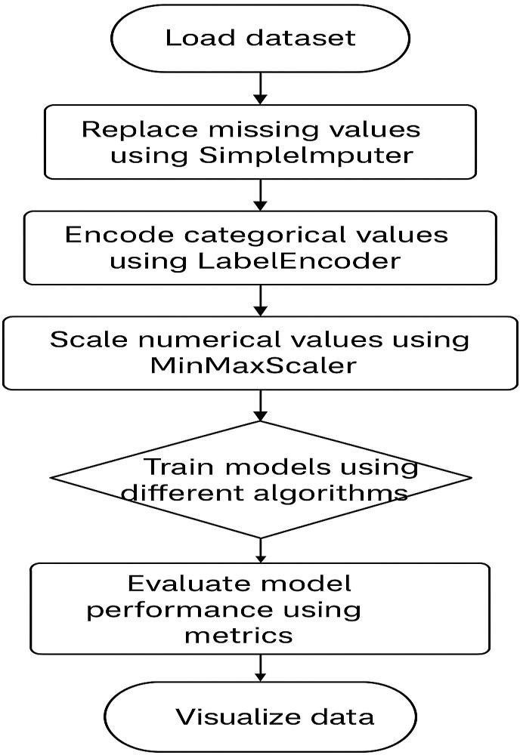

- Dataset Design:

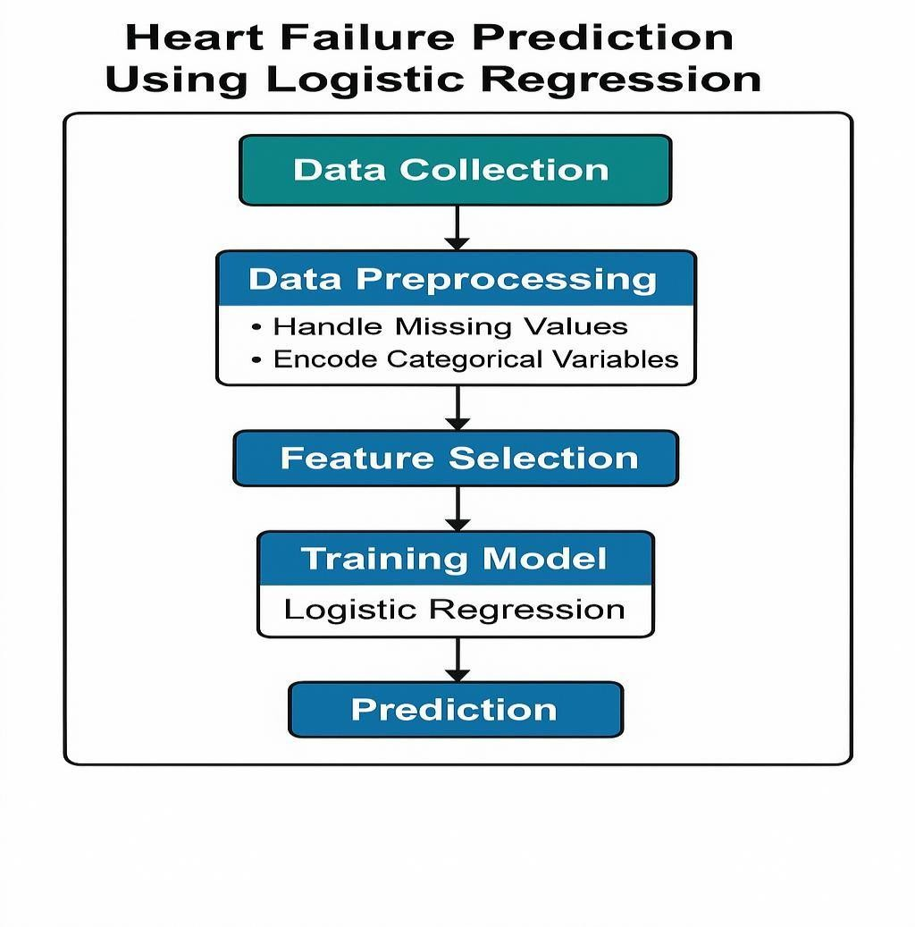
Details on preprocessing steps applied:

    - Missing Values: Filled using SimpleImputer (mean for numerical, most frequent for categorical)
    - Categorical Encoding: LabelEncoder applied to all object type columns
    - Feature Scaling: MinMaxScaler used on numerical columns to normalize them between 0 and 1.

- Development

Source Code :

import pandas as pd
import numpy as np
import seaborn as sns
import matplotlib.pyplot as plt

from sklearn.model_selection import train_test_split
from sklearn.preprocessing import LabelEncoder, MinMaxScaler
from sklearn.impute import SimpleImputer

# Models
from sklearn.linear_model import LogisticRegression
from sklearn.neighbors import KNeighborsClassifier
from sklearn.tree import DecisionTreeClassifier
from sklearn.ensemble import RandomForestClassifier
from sklearn.svm import SVC
from sklearn.naive_bayes import GaussianNB
from sklearn.metrics import classification_report

# Evaluation
from sklearn.metrics import accuracy_score, confusion_matrix, classification_report

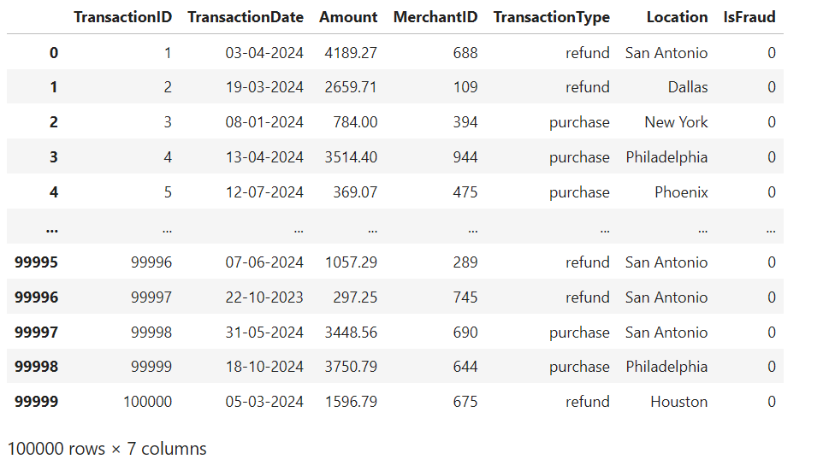
# 1. Load Dataset

df = pd.read_csv("D:/zaalima/credit_card_fraud_dataset.csv")
df

# 2. Handle Missing Values

print("Dataset preview: ")
print(df.head())
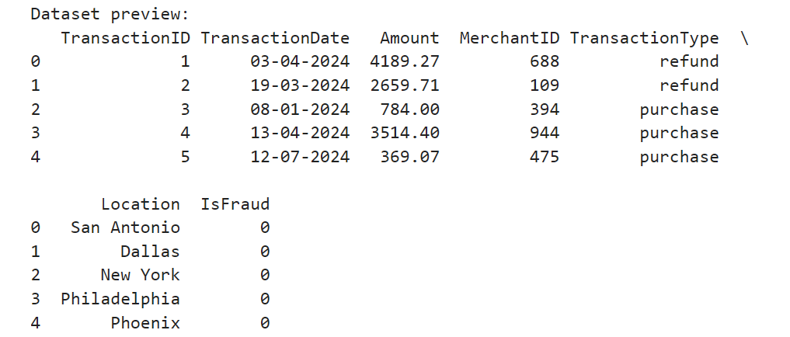
print(df.dtypes)
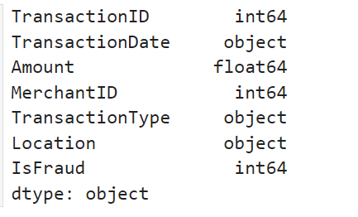
num_cols = df.select_dtypes(include=['int64','float64']).columns.tolist()
cat_cols = df.select_dtypes(include=['object']).columns.tolist()

print("\n numeric columns: ")
print(num_cols)
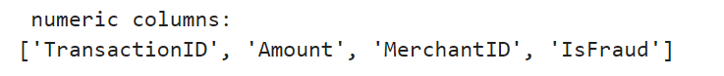

print("\n categorical columns: ")
print(cat_cols)
print("Missing values before cleaning:")
print(df.isnull().sum())
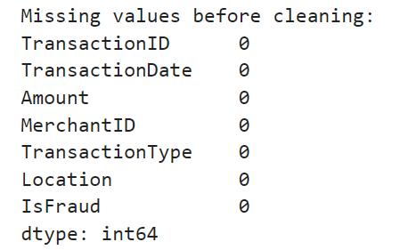
num_imputer = SimpleImputer(strategy="mean")
df[num_cols] = num_imputer.fit_transform(df[num_cols])
cat_imputer = SimpleImputer(strategy="most_frequent")
df[cat_cols] = cat_imputer.fit_transform(df[cat_cols])
# 3. Encode Categorical

le = LabelEncoder()
for col in df.select_dtypes(include=['object']).columns:
df[col] = le.fit_transform(df[col])

# 4. Choose Target Column

if "IsFraud" in df.columns:
target = "IsFraud"
else:
# fallback: last column ko target maan lo
target = df.columns[-1]

print("Target Selected:", target)

results = {}

for name, model in models.items():
model.fit(X_train, y_train)
y_pred = model.predict(X_test)

acc = round(accuracy_score(y_test, y_pred)*100, 2)
results[name] = acc

print("\n===============================")
print(f" {name}")
print("Accuracy:", acc, "%")
print("Confusion Matrix:\n", confusion_matrix(y_test, y_pred))
print("Classification Report:\n", classification_report(y_test, y_pred, zero_division=0))
#Train Models
models = {
"Logistic Regression": LogisticRegression(max_iter=500),
"KNN": KNeighborsClassifier(n_neighbors=5),
"Decision Tree": DecisionTreeClassifier(random_state=42),
"Random Forest": RandomForestClassifier(n_estimators=100, random_state=42),
"SVM (RBF)": SVC(kernel="rbf", probability=True),
"Naive Bayes": GaussianNB()
}
# 6. Train-Test Split
X_train, X_test, y_train, y_test = train_test_split(
X, y, test_size=0.3, random_state=42, stratify=y
)
# 5. Feature Scaling
from sklearn.preprocessing import MinMaxScaler

# Identify numeric columns again
num_cols = df.select_dtypes(include=['int64','float64']).columns.tolist()

# Remove target column if present
if "IsFraud" in num_cols:
num_cols.remove("IsFraud")

# Apply scaling
scaler = MinMaxScaler()
X[num_cols] = scaler.fit_transform(X[num_cols])
X = df.drop(columns=[target])
y = df[target]

===============================
Logistic Regression
Accuracy: 99.0 %
Confusion Matrix:
[[29700 0]
[ 300 0]]
Classification Report:
precision recall f1-score support

0.0 0.99 1.00 0.99 29700
1.0 0.00 0.00 0.00 300

accuracy 0.99 30000
macro avg 0.49 0.50 0.50 30000
weighted avg 0.98 0.99 0.99 30000

===============================
KNN
Accuracy: 99.0 %
Confusion Matrix:
[[29700 0]
[ 300 0]]
Classification Report:
precision recall f1-score support

0.0 0.99 1.00 0.99 29700
1.0 0.00 0.00 0.00 300

accuracy 0.99 30000
macro avg 0.49 0.50 0.50 30000
weighted avg 0.98 0.99 0.99 30000

===============================
Decision Tree
Accuracy: 97.86 %
Confusion Matrix:
[[29355 345]
[ 297 3]]
Classification Report:
precision recall f1-score support

0.0 0.99 0.99 0.99 29700
1.0 0.01 0.01 0.01 300

accuracy 0.98 30000
macro avg 0.50 0.50 0.50 30000
weighted avg 0.98 0.98 0.98 30000

===============================
Random Forest
Accuracy: 99.0 %
Confusion Matrix:
[[29700 0]
[ 300 0]]
Classification Report:
precision recall f1-score support

0.0 0.99 1.00 0.99 29700
1.0 0.00 0.00 0.00 300

accuracy 0.99 30000
macro avg 0.49 0.50 0.50 30000
weighted avg 0.98 0.99 0.99 30000

===============================
SVM (RBF)
Accuracy: 99.0 %
Confusion Matrix:
[[29700 0]
[ 300 0]]
Classification Report:
precision recall f1-score support

0.0 0.99 1.00 0.99 29700
1.0 0.00 0.00 0.00 300

accuracy 0.99 30000
macro avg 0.49 0.50 0.50 30000
weighted avg 0.98 0.99 0.99 30000

===============================
Naive Bayes
Accuracy: 99.0 %
Confusion Matrix:
[[29700 0]
[ 300 0]]
Classification Report:
precision recall f1-score support

0.0 0.99 1.00 0.99 29700
1.0 0.00 0.00 0.00 300

accuracy 0.99 30000
macro avg 0.49 0.50 0.50 30000
weighted avg 0.98 0.99 0.99 30000

#Accuracy Comparison Plot
plt.figure(figsize=(8,5))
sns.barplot(x=list(results.keys()), y=list(results.values()), palette="viridis")
plt.title("Model Accuracy Comparison")
plt.ylabel("Accuracy %")
plt.xticks(rotation=30)
plt.show()

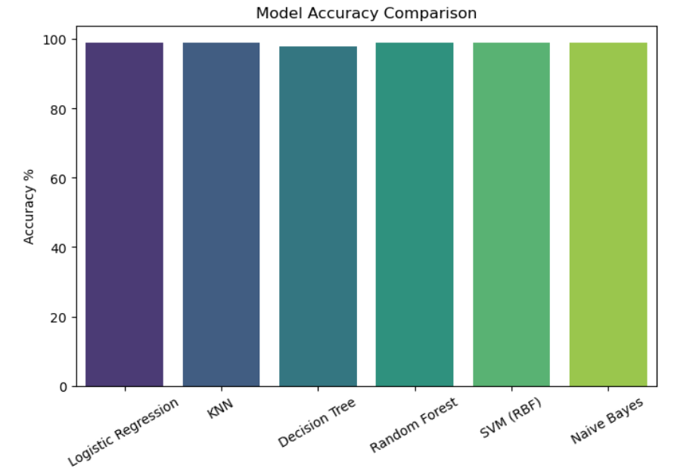

#Scatter Graph
if "Amount" in df.columns and "MerchantID" in df.columns:
plt.figure(figsize=(10, 6))
sns.scatterplot(x=df["Amount"], y=df["MerchantID"], hue=df["IsFraud"], palette="Set1", alpha=1)
plt.title("Scatter Plot: Amount vs MerchantID (Colored by IsFraud)", fontsize=14)
plt.show()

#Feature Corelation Heatmap
plt.figure(figsize=(12, 8))
sns.heatmap(df.corr(), annot=True, cmap="coolwarm", fmt=".2f", linewidths=0.5)
plt.title("Feature Correlation Heatmap")
plt.show(block=False)

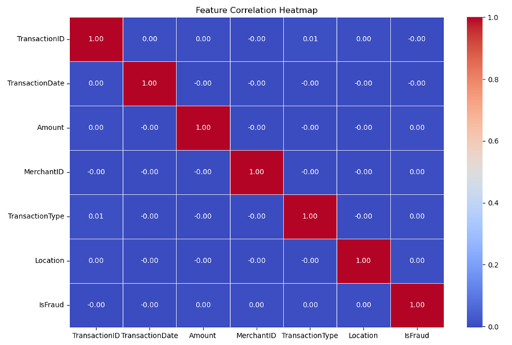

#Scatter Graph
if "Amount" in df.columns and "MerchantID" in df.columns:
plt.figure(figsize=(10, 6))
sns.scatterplot(x=df["Amount"], y=df["MerchantID"], hue=df["IsFraud"], palette="Set1", alpha=1)
plt.title("Scatter Plot: Amount vs MerchantID (Colored by IsFraud)", fontsize=14)
plt.show()

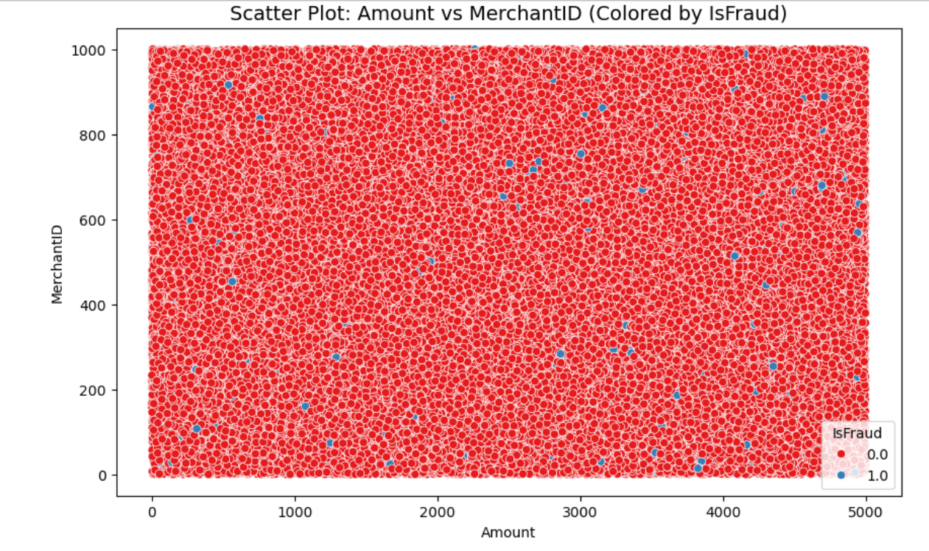

#Box Plot
fig, axes = plt.subplots(1, len(num_cols), figsize=(15, 5))
for i, col in enumerate(num_cols):
sns.boxplot(x=y, y=df[col], ax=axes[i])
axes[i].set_title(f"{col} vs {target}")
plt.tight_layout()
plt.show()

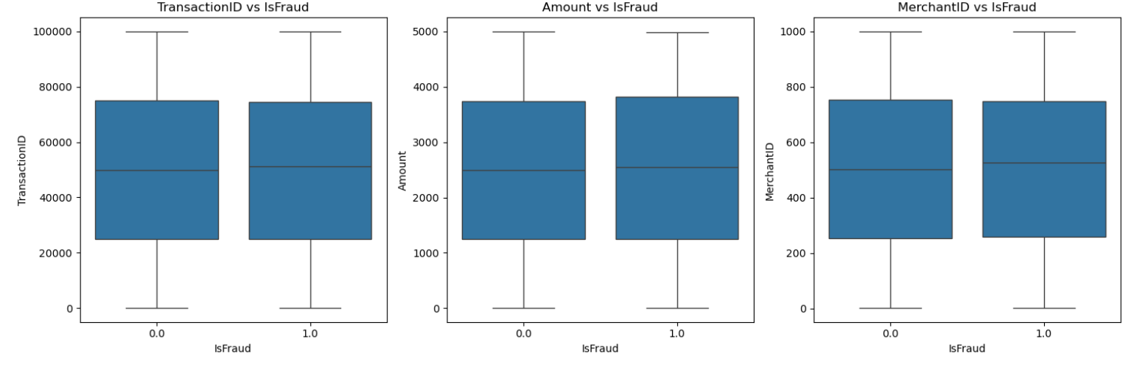

# Histogram for all numerical columns dynamically
fig, axes = plt.subplots(len(num_cols), 1, figsize=(10, 4 * len(num_cols)))

for i, col in enumerate(num_cols):
sns.histplot(df[col], bins=30, kde=True, ax=axes[i])
axes[i].set_title(f"Histogram of {col}")

plt.tight_layout()
plt.show()

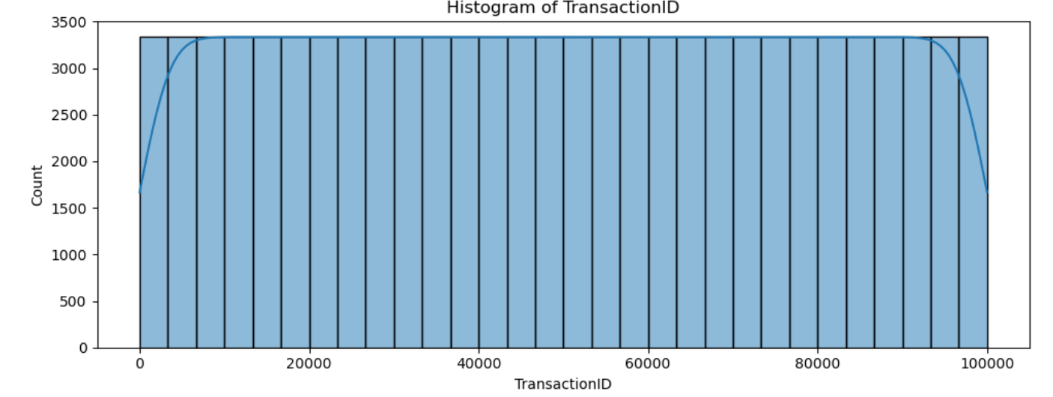
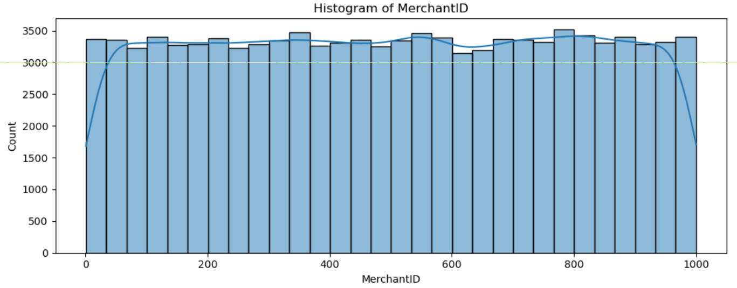
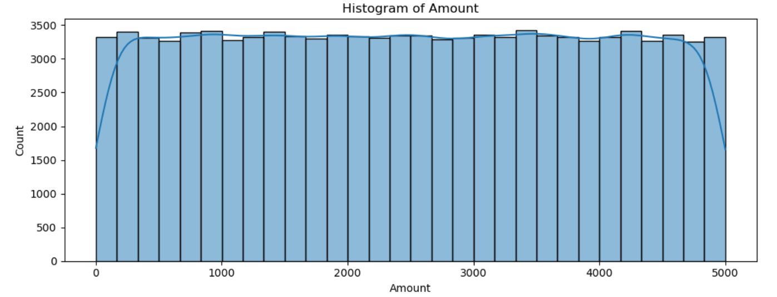
new_data = pd.DataFrame([{
"TransactionID": 1000001,
"TransactionDate": "5-3-2024",
"Amount": 280.25,
"MerchantID": 611,
"TransactionType": "refund",
"Location": "Maxico"
}])

# Apply same encoding
new_data = pd.get_dummies(new_data)

# Align columns with training data
new_data = new_data.reindex(columns=X_train.columns, fill_value=0)

# Predict
pred_class = model.predict(new_data)[0]

print("Prediction:", pred_class)



SYSTEM TESTING

System testing ensures that the complete fraud detection system works correctly after development. It verifies that data preprocessing, model training, and prediction modules function as expected. All components are tested together to confirm accuracy, reliability, and correct flow of data.

- TESTING AND IMPLEMENTATION

Testing

1. Unit Testing
To test each part separately:
- Data loading
- Data preprocessing
- Model training
- Model evaluation

2. Integration Testing
To check if modules work together smoothly:
- Preprocessed data passed to model
- Model output passed to evaluation metrics

3. Performance Testing
To measure model accuracy, precision, recall, and F1-score on the given dataset.

4. Validation Testing
Split dataset into training and testing sets to ensure the model performs well on unseen data.

Implementation

1. Development Environment Setup
- Install Python
- Install libraries (NumPy, Pandas, Scikit-Learn)
- Use Jupyter Notebook for coding

2. Data Preparation
- Load dataset
- Clean and preprocess data
- Balance classes using undersampling/SMOTE

3. Model Implementation
- Train different ML models
- Compare performance
- Select best model based on recall and F1-score

4. Testing & Validation
- Use train-test split
- Validate model using evaluation metrics

5. Deployment (Optional)
- Save model using pickle
- Load model in a Python script
- Use it to predict new transaction fraud

CONCLUSION

This project successfully demonstrates how machine learning can be used to detect credit card fraud using the given dataset. After preprocessing the data and handling class imbalance, the trained model was able to identify fraudulent transactions with good accuracy and recall. The results show that machine learning provides an effective and reliable method for fraud detection, helping financial systems reduce risks and improve security.

LEARNING DURING PROJECT WORK

During this project, I learned how to handle real datasets, preprocess data, and apply machine learning models for fraud detection. I understood how to evaluate model performance and gained practical experience with Python, Jupyter Notebook, and ML libraries. This project improved my technical skills and helped me understand how machine learning can solve real-life problems.

FUTURE ENHANCEMENTS

1. Integration of Deep Learning Models
- Use LSTM for analyzing transaction sequences.
- Use Autoencoders and Neural Networks for anomaly detection.
2. Real-Time Prediction System
Implement fraud detection on streaming data using:
- Apache Kafka
- Spark Streaming
- Cloud-based real-time systems
3. Deployment as a Web / Mobile Application
Build an API-based model using:
- Flask / FastAPI
- Deploy to AWS/GCP/Azure
Banks can integrate it into their transaction systems.
4. Use of Graph-Based Fraud Detection
Graph analytics can detect:
- Network-level fraud rings
- Linked credit card fraud patterns
5. Feature Engineering Improvements
Add additional features from real transaction logs:
- Location
- Device Type
- Merchant Category
- Historical spending behavior
6. Explainable AI (XAI)
Use SHAP or LIME to explain model predictions to auditors and banking staff.
7. Continuous Learning
Create a system that updates itself with new fraud patterns using online training.

BIBLIOGRAPHY

Online references:

- www.youtube.com
- www.w3school.com
- www.geeksforgeeks.org
- Many Other Websites

Offline references:

- Introduction to Machine Learning with Python
- Machine Learning: A Probabilistic Perspective
- Pattern Recognition and Machine Learning

